Executive Summary

Many stroke survivors have difficulty donning a shoe on their weaker foot due to weakness on one side of the body. Stroke survivors frequently experience foot-drop due to lower extremity weakness as well. Physical therapists often recommend the use of an Ankle-Foot Orthosis (AFO), a hard plastic brace that keeps the foot from falling down during ambulation. Stroke survivors find it difficult to don a shoe because the AFO is bulky and does not easily slide into the shoe. This difficulty is compounded by the fact that stroke survivors only have one arm and one leg to use when putting on the AFO. The goal of this project was to increase the independence and efficiency with which a stroke survivor can don an AFO and shoe.

Our group went down to the Rehabilitation Institute of Chicago to observe stroke survivors attempting to don their shoes. We observed that most users had developed a method to don their shoes. The most common method was to rest the weak leg on top of the strong leg. This allowed the user to maneuver the shoe using their strong side of their body. Unfortunately, due to weakness from the stroke, users were unable to hold their weak leg up, and it slid off, keeping them from donning their shoe. Our group identified this as the fundamental problem to address in designing a solution.

The iHold was designed to keep the weak leg in place while users put on their shoe over their AFO. Portable yet capable of withstanding large forces, the iHold revolves around a folding flap that prevents the weak leg from sliding off the strong leg. The iHold gives users leverage by allowing them to use their strong side of their body to work their shoe onto their foot. This greatly improves the ability with which stroke survivors can don their shoe. It allows them to don their shoe quickly, but it also allows the user to don their shoe independently. In this way, the iHold can easily be incorporated into the daily routine of stroke survivors. It both helps them and empowers them. Most importantly, it builds on the technique they are taught at the RIC. The final design is pictured below.

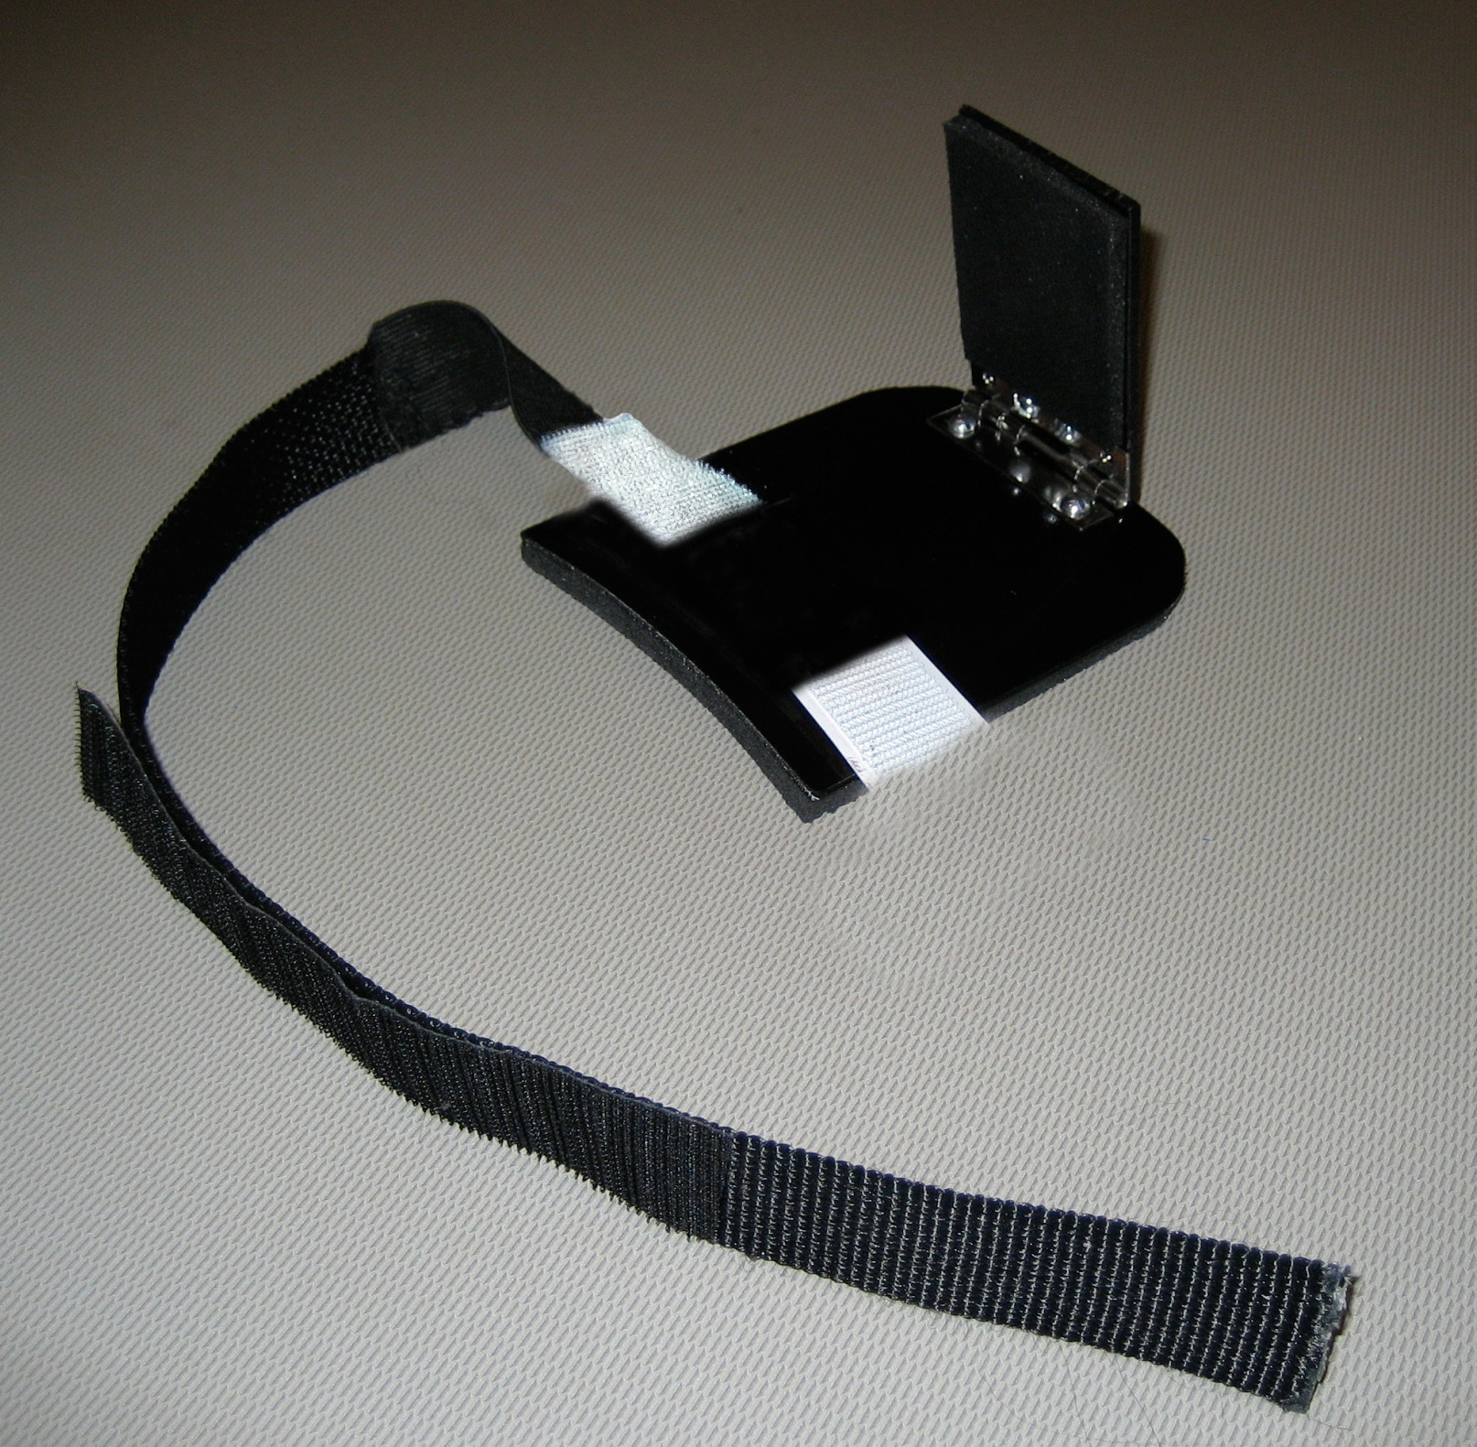
Figure 1: Final Prototype: iHold

